**CS/ECE374 Assignment 1**

01/26/2023

**Group & netid**

*Chen Si chensi3*

*Jie Wang jiew5*

*Shitian Yang sy39*

**Problem 1**

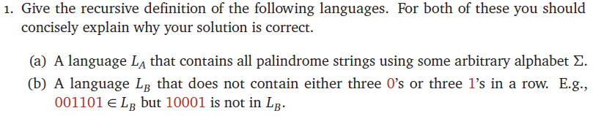

Answer:

(a) Recursive Definition:

(1) $ϵ∈L_{A}$

(2) $a∈L_{A}$ for some single symbol $a∈Σ$

(3) if $w=axa$ for some single symbol $a∈Σ$ and for some $x∈L_{A}$, $w∈L_{A}$

Explanation:

Base Case:

(1) For a length 0 string (empty string $ϵ$), as it satisfies the definition of a palindrome, we need to include it in the base cases.

(2) For a length 1 string (single character $a∈Σ$), as it satisfies the definition of a palindrome, it can also be included in the base cases.

Inductive Step:

(3) For strings of length greater than 1 that satisfies the palindrome definition, we treat in odd and even case:

(i) if the string length is odd, since its first and last characters are the same, we could obtain it by adding the character to an inner string of odd length which satisfies the palindrome definition, and it would recurse down to rule (2).

(ii) if the string length is even, since its first and last characters are the same, we could obtain it by adding the character to an inner string of even length which satisfies the palindrome definition, and it would recurse down to rule (1).

(b) Recursive Definition:

Define $L_{0}$ to be the set of strings in $L_{B}$ that starts with 0 and $L_{1}$ to be the set of strings in $L_{B}$ that starts with 0.

For $L_{0}$:

(1) $ϵ∈L_{0}$

(2) $0x∈L_{0}$, if $x∈L_{1}$

(3) $00x∈L_{0}$, if $x∈L_{1}$

For $L_{1}$:

(1) $ϵ∈L_{1}$

(2) $1x∈L_{1}$, if $x∈L_{0}$

(3) $11x∈L_{1}$, if $x∈L_{0}$

Therefore, we could get $L_{B}=L_{0}∪L_{1}$

Explanation:

In the definition of $L_{B}$, we could see that the strings are composed of “building blocks” of 0, 1, or 2 zeros and 0, 1, 2 ones. With this, we could separate the process of adding building blocks to the newly constructed string into adding 0s and adding 1s. We then separate $L_{B}$ into $L_{0}$, whose job is to add 0s, and $L_{1}$, whose job is to add 1s, this ensures that before adding 0s, the last character added must be empty or 1, and that before adding 1s, the last character added must be empty or 0, which ensures that no 3 consecutive 0s or 1s would be added together.